New Student Membership Application

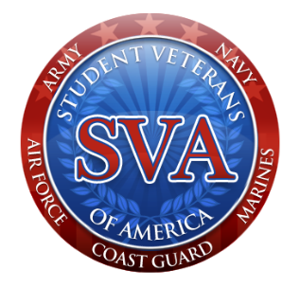

Welcome to West Virginia State University and congratulations on your decision to continue your education. Whether you are a veteran or not, the SVA is glad to have you be a part of our organization. The SVA is not military based, we are a group of students, veterans, and civilians who wish to assist other veterans the best we can. Along with helping veterans, we also like to help out the community. Please feel free to visit our website:www.facebook.com/wvsusva

Regular Membership of the SVA shall be open to all registered students at West Virginia State University who are actively registered (full or part time) and maintain an overall GPA of 2.0.

Name: _______________________________________________________________

Phone: _________________ Email: _______________________________________

Major: _______________________________________________________________

GPA: ____________A#: ________________________________________________

Signature: _____________________________Date: ________________________

Return this application to 333 Sullivan Hall East or by email to:

militarystudentservices@wvstateu.edu

